Observation of robust subwavelength phase singularity in chiral medium

Jun-Hee Parkª, Jeongho Haª, Liyi Hsuª, Guang Yang^{b}, Yeshaiahu Fainmanª, Alexander Sergienko^{b}, and Abdoulaye Ndao^{a,b}

ªUniversity of California, San Diego, Department of Electrical and Computer Engineering, La Jolla, California, United States
^{b}Boston University, Photonics Center, Department of Electrical and Computer Engineering, Boston, Massachusetts, United States

Coupled mode theory (CMT)
The transmission of our designed nanostructures—the main cause of the observed large phase modulation—can be qualitatively understood by modeling the system within the framework of coupled mode theory (CMT). We started with the simplest case which consists of a single-mode optical resonator coupled with one port. The dynamic equations for the amplitude a of the resonance mode can be expressed as [Ref 46]
$\frac{da}{dt}=-iw_{1}a-Γ_{1}a+α_{1}s_{1+}$ (1)
$s_{1-}=β_{1}s_{1+}+g_{1}a$ (2)
where $ω_{1},Γ_{1}$ are the real part and the image part (loss rate) of the resonance frequency respectively; $s_{1+},s_{1-}$ are the incoming wave and reflected wave respectively; constants $α_{1},g_{1}$ represent the strength of the coupling and $β_{1}$ is a proportionality constant. By solving the equations above, we can have the reflection coefficient ${r=s}_{1-}/s_{1+}$ as
$r=\frac{α_{1}g_{1}}{-i\left(ω-ω_{0}\right)+Γ_{1}}+β_{1}$ (3)
Consider there are two loss mechanisms, radiation $(Γ_{r})$ and absorption loss $(Γ_{a})$, we have $Γ_{1}$ = $Γ_{r}+ Γ_{a}$. For the process of leaking out and there is no input energy, $s_{1+}=0$ and the mode decays exponentially as $a\left(t\right)=a\left(0\right)exp\left(-iω_{1}t-Γ_{r}t\right)$ , and thus the energy $\left|a^{2}\right|$ is decreasing. The only place for this energy is into the outgoing power ${\left|s_{1-}\right|}^{2}$. Thus, we have
$-\frac{d{\left|a\right|}^{2}}{dt}=2Γ_{r}{\left|a\right|}^{2}={\left|s_{1-}\right|}^{2}={\left|g_{1}\right|}^{2}{\left|a\right|}^{2}$ (4)
Therefore,${\left|g_{1}\right|}^{2}=2Γ_{r}$, and since the phase of $s_{1-}$ is arbitrary, we can choose $g_{1}=\sqrt{2Γ_{r}}$. Secondly, by time-reversal symmetry, we can observe that for $s_{1+}=0$, the cavity mode decays, and the output fields are given by $s_{1-}=\sqrt{2Γ_{r}}a$. Also, we can obtain another solution of the equations by running the original solution backwards in time and conjugating to retain an $exp\left(-iω_{1}t\right)$ time dependence. To be more specific, we can have a solution to equation (1) of the form $a\left(t\right)=a\left(0\right)exp\left(-iω_{1}t+Γ_{r}t\right)$ (exponentially growing) with input fields $s_{1+}=\sqrt{2Γ_{r}}a$
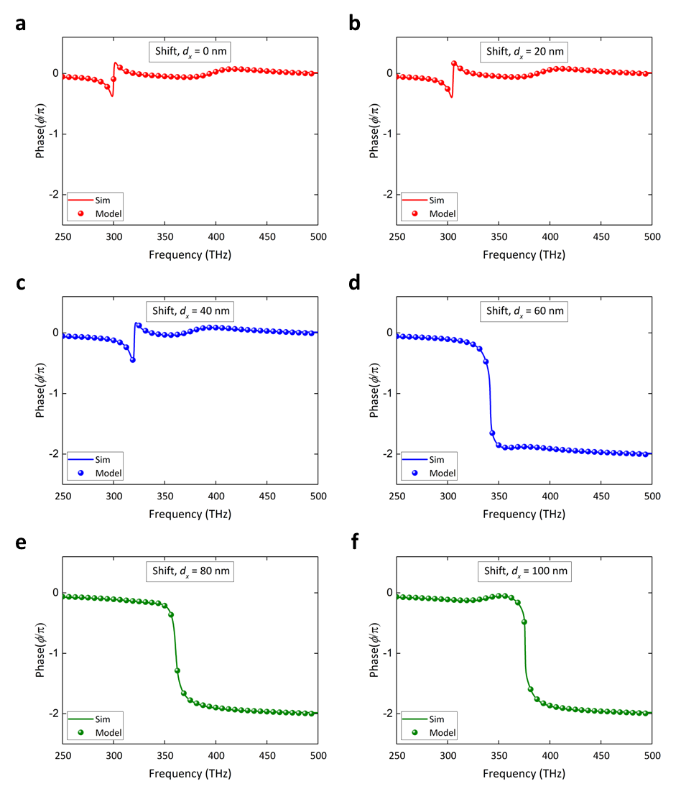
Fig. S1. The phase response of transmission from the plasmonic twisted resonators for different lateral displacements of top nanorod, a - f, d_{x} = 0, to 100 nm. The coupled mode theory (dot) and numerical simulation (solid line) shows a good agreement in phase response with different lateral shift (d_{x}).

and zero output fields $s_{1-}=0$. Plugging those into equation (1), we have $α_{1}=\sqrt{2Γ_{r}}=g_{1}$. Thus, the reflection coefficient $r$ in equation (3) can be re-written as
$r=\frac{2Γ_{r}}{-i\left(ω-ω_{0}\right)+Γ_{r}+Γ_{a}}+β_{1}$ (5)
A more general expressions for the two-port, single-mode model yields [Ref 47]
$r=r_{0}e^{iΦ_{r0}}+\frac{Γ_{r}e^{iΦ}}{i\left(ω-ω_{0}\right)-Γ_{r}-Γ_{a}}$ (6)
$t=t_{0}e^{iΦ_{t0}}+\frac{Γ_{r}e^{iΦ}}{i\left(ω-ω_{0}\right)-Γ_{r}-Γ_{a}}$ (7)
The first term is for background medium, and the second term describes resonance behavior. In our device, there are two modes rather than a single mode, so we have two resonance terms instead of 1 resonance term. Hence, the equations have a second resonance term as
$t=t_{0}e^{iΦ_{0}}+\frac{Γ_{1r}e^{iΦ_{1}}}{i\left(ω-ω_{1}\right)-Γ_{1r}-Γ_{1a}}+\frac{Γ_{2r}e^{iΦ_{2}}}{i\left(ω-ω_{2}\right)-Γ_{2r}-Γ_{2a}}$ (8)
ω₁ and ω₂ here is the coupled angular frequencies and it can be expressed with un-coupled angular frequencies (ω₁’, ω₂’), un-coupled loss rates ($Γ$ ₁’, $Γ$ ₂’) and its coupling coefficient ($κ_{12}, κ_{21}$). As a next step, we revisit Eq. (1) for the case of two weakly coupled resonators (coupling coefficient $κ_{12}, κ_{21}$) with loss included and set the incident wave ($s_{1+}$) equal to zero.
$\frac{da_{1}'}{dt}=-iw_{1}^{'}a_{1}'-Γ_{1}^{'}a_{1}'-κ_{12}a_{2}'$ (9)
$\frac{da_{2}'}{dt}=-iw_{2}^{'}a_{2}'-Γ_{2}^{'}a_{2}'-κ_{21}a_{1}'$ (10)
To solve the coupled differential equations, we form the system matrix and set its determinant to zero to extract the frequencies of the coupled system and obtain a non-trivial solution [Ref 48],
$\left|\begin{matrix}-i\left(w_{1}^{'}-\tilde{ω}\right)-Γ_{1}^{'} & -κ_{12} \\ -κ_{21} & -i\left(w_{2}^{'}-\tilde{ω}\right)-Γ_{2}^{'}\end{matrix}\right|=0$ (11)
$\tilde{ω_{1,2}}=\frac{1}{2}\left(H±\sqrt{Δ}\right)=ω_{1,2}-i\left(Γ_{1,2r}+Γ_{1,2a}\right), Δ=B^{2}+4D$ (12)
$D=-ω_{1}^{'}ω_{2}'+Γ_{1}^{'}Γ_{2}'-κ_{12}κ_{21}+iω_{1}^{'}Γ_{2}'+iω_{2}'Γ_{1}'$ (13)
$B=ω_{2}^{'}+ω_{1}^{'}-iΓ_{1}^{'}-iΓ_{2}'$ (14)
Figure S1 shows the phase response of transmission (RCP) for the coupled mode theory and numerical simulation results with different lateral shift d_{x}. The large phase modulation (0 to 2π) occurs for the lateral shift, 60, 80 and 100 nm, respectively. One can observe a good agreement between the CMT and numerical simulation in phase responses.

Device fabrication
Figure S2 presents the fabrication process of the multilayered chiral plasmonic nanostructure using a two-step electron beam lithography (EBL) and a lift-off process. Firstly, a BK7 glass substrate was cleaned with a basic organic cleaning process at the ultrasonic bath (Acetone => IPA), and then N2 blow was used to dry the sample. We employed a typical bilayer resist process to improve the sidewall sharpness of nanorods. The copolymer with a thickness of 160 nm (EL 11, Kayaku) was spin-coated on the substrate to achieve the large difference in dissolution rates of the resist layers at the developer step. Next, a 50 nm thick PMMA (950PMMA A2, Kayaku) was spin-coated on the copolymer layer and followed by a soft-bake step for 5 min at 180°C on a hot plate. We used a 50 keV EBL system (Elionix, ELS HS50) to expose the electron beam to the bilayer resists. Then, the cold development process (5°C, 1:3 MIBK: IPA, Kayaku) was applied to improve pattern resolution. After the development process, a 2 nm chromium layer was deposited as an adhesion layer, and then a 38 nm gold layer was deposited using an electron beam evaporation system (Angstrom Engineering, EVOVAC). The sample was soaked into a resist remover at 70°C to clean all the resists for the lift-off process. Finally, the first layer of the nanorods array was transferred to the BK7 substrate.
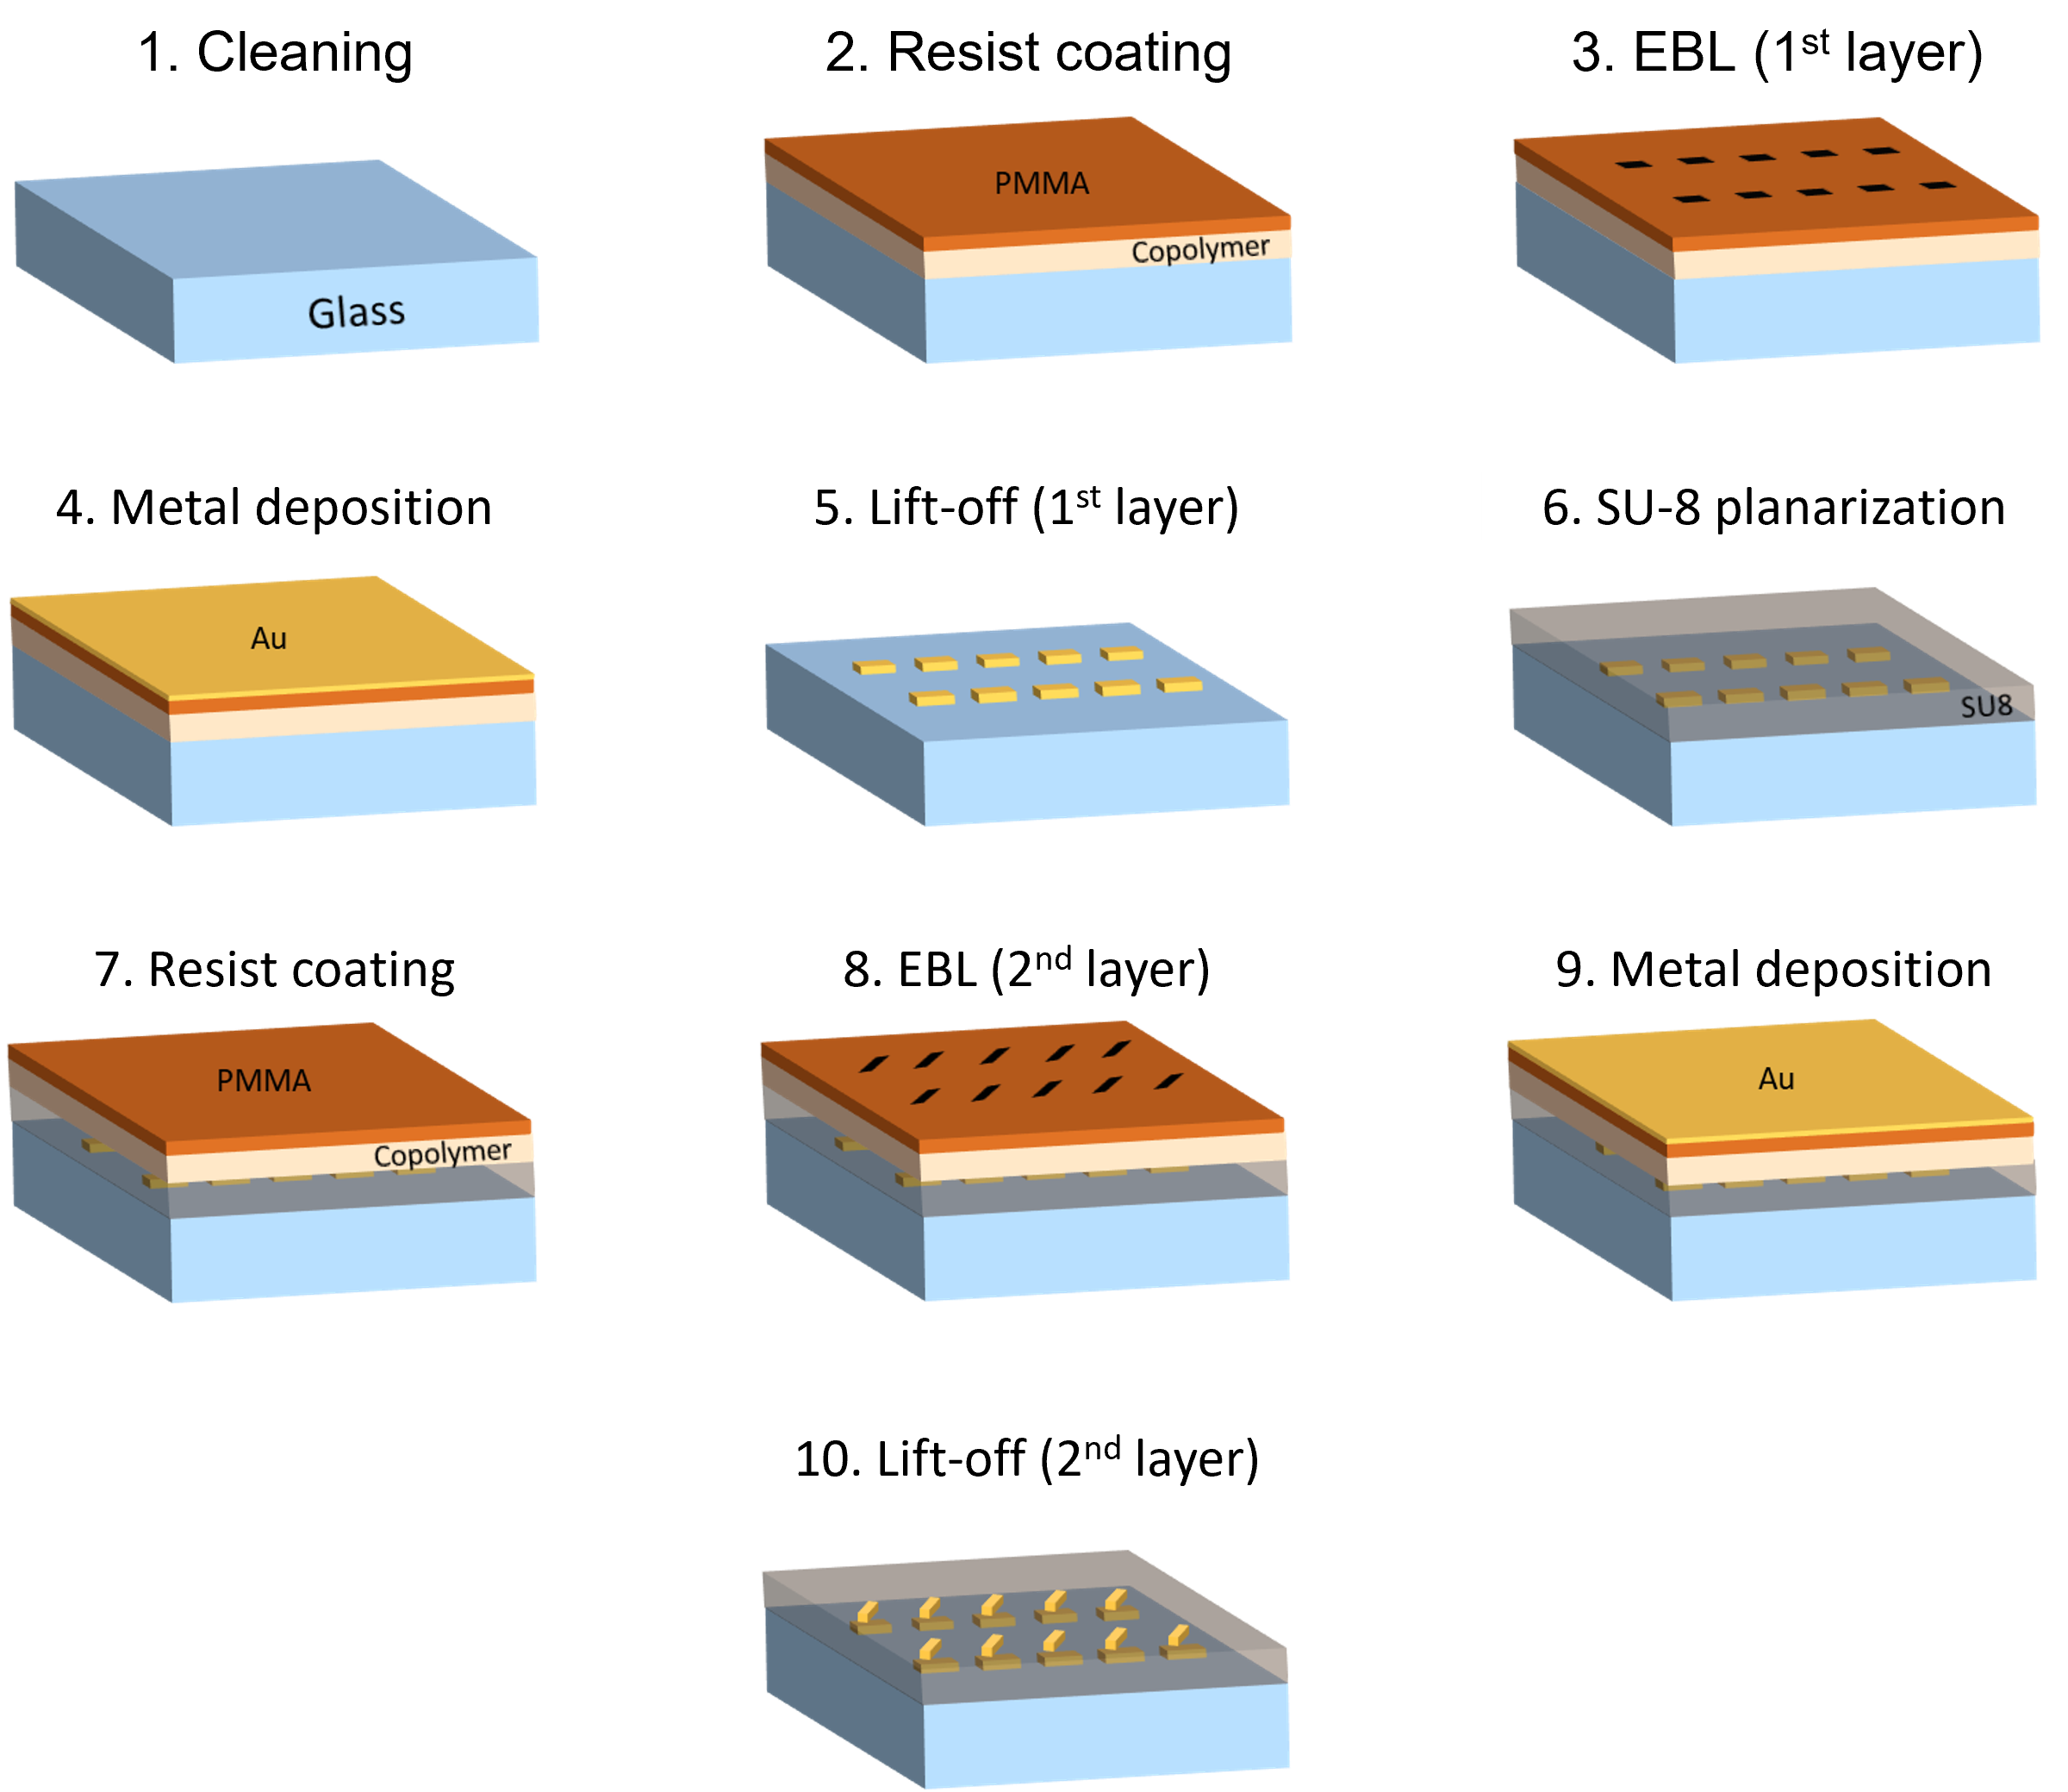
Fig. S2. Fabrication process of the multilayered chiral plasmonic nanostructures.
A 60-nm-thick layer of SU-8 is spin-coated to make a spacer between the first and second nanorods array. Subsequently, we planarized the topographic surface with thermal treatment. The substrate was baked at 65°C and then at 95°C. The SU-8 crosslinking via UV light exposure and hard baking on a hot plate at 200°C were carried out and cooled down naturally to room temperature. The second layer of the EBL procedure was similar to the one used for the first layer. We performed the precise auto-alignment steps with global and local alignment markers, improving alignment errors below 5 nm. The metallization and lift-off process were carried out, and the second nanorods array with twisted angle patterns was transferred to the SU-8 layer. Figure S3 shows the SEM images of the fabricated plasmonic chiral structures with two different twisted angles ($θ$ = + 30º and – 30º) and lateral displacements (d_{x} = 0, 20, 40, 48 58, 60, 80, and 100 nm, respectively).
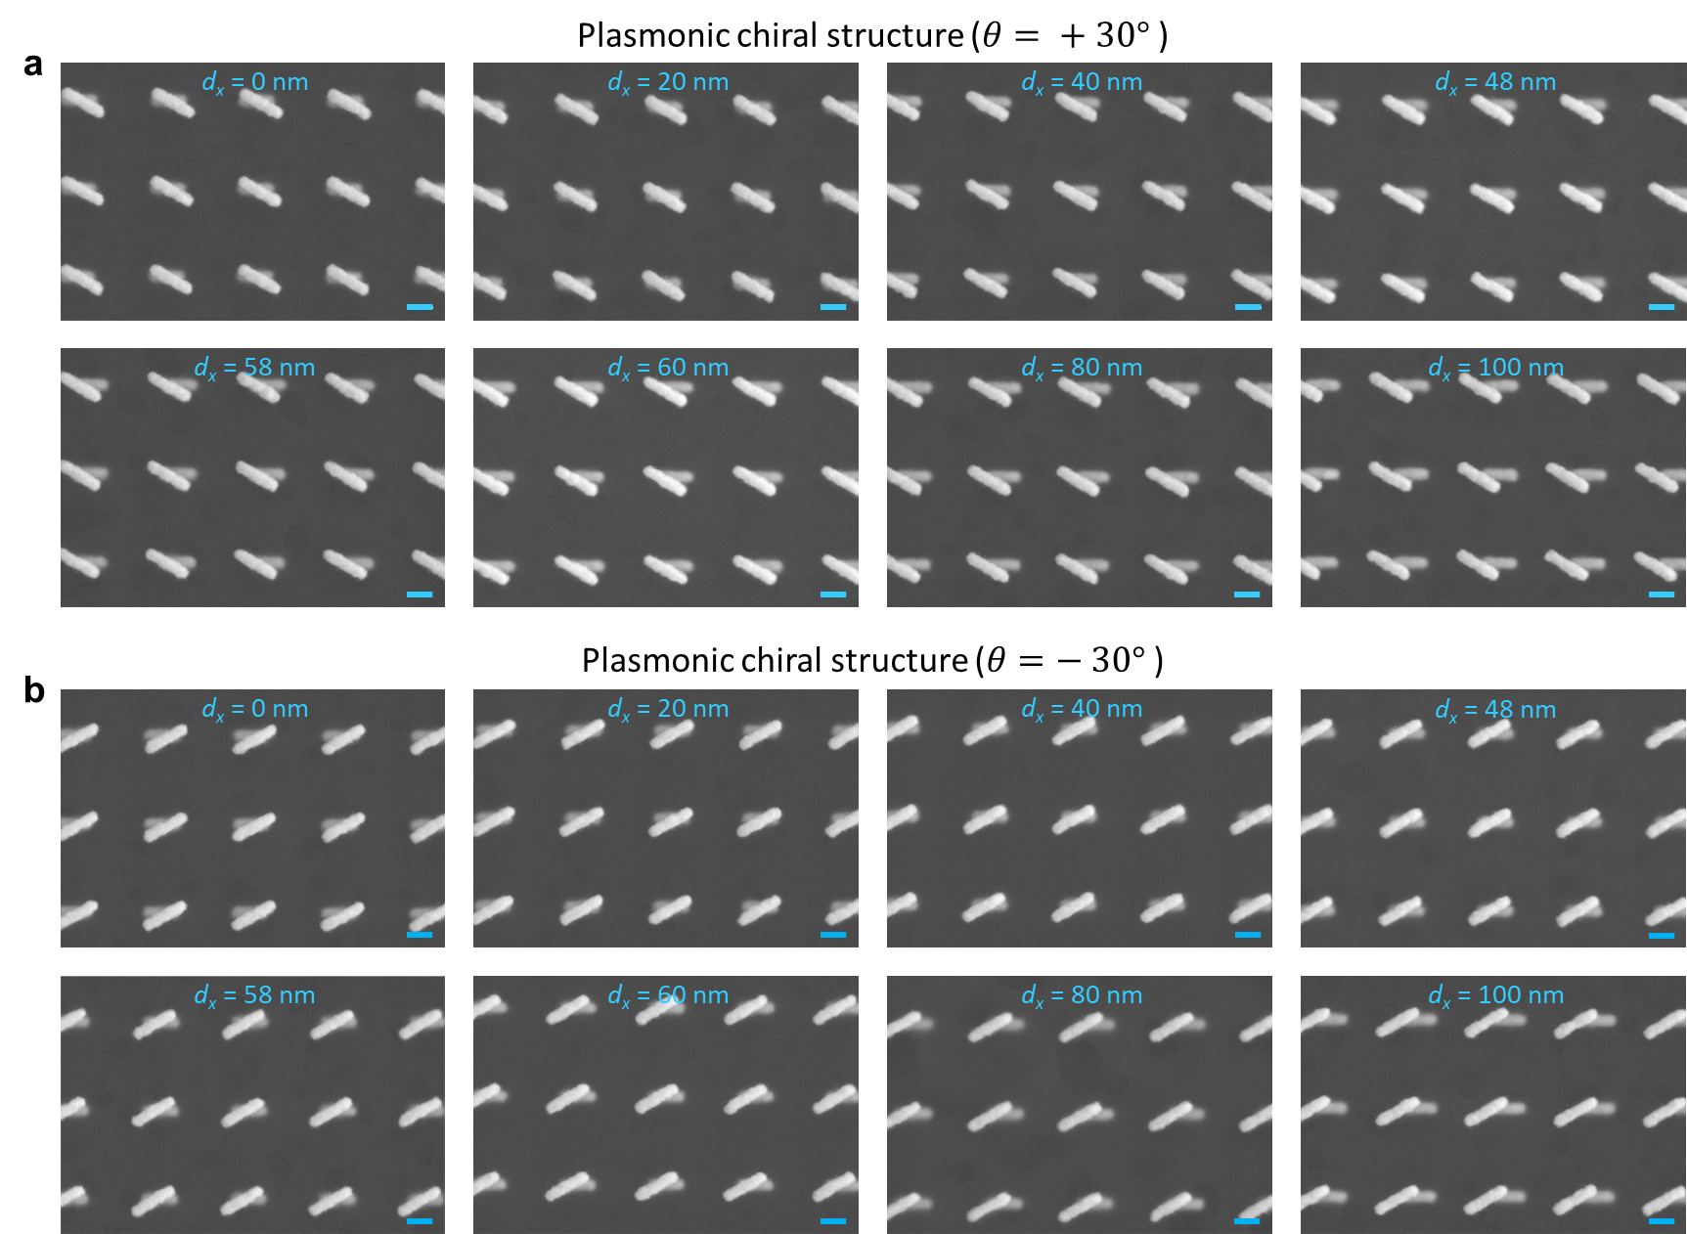
Fig. S3 SEM images of plasmonic chiral structure with different twisted angle ($θ$ = + 30º and – 30º) and lateral displacements (d_{x} = 0, 20, 40, 48, 58, 60, 80, and 100 nm, respectively). a) top-view image of + 30º plasmonic chiral structure. b) – 30º plasmonic chiral structure. The scale bars are 100 nm.

Next, we evaluated the thickness and uniformity of the SU-8 spacer layer. A focused ion beam with a scanning electron microscope (FIB-SEM, FEI Helios 660) system was used to obtain cross-sectional images of the fabricated bilayer chiral nanostructures. Firstly, a 20 nm platinum layer was deposited over the sample by DC sputtering to avoid electrostatic charging. Then, we partially deposited a platinum layer of more than 500 nm using a FIB to preserve surface features during the subsequent ion-etching process. Figure S4 shows SEM images of the fabricated bilayer chiral nanostructure. The red and yellow boxes in Fig. S4 a represent the horizontal and vertical directions of FIB milling scans. The cross-sectional view images from the FIB milling process in Fig. S4 b and c validate a high degree of uniformity over the SU-8 spacer layer without significant thickness variations. The measured thickness of the spacer layer (h_{s}) is 60 nm with ± 2 nm variation. The SU-8 layer and planarization process resulted in outstanding uniformity and well-defined nano-features with minimal variations.
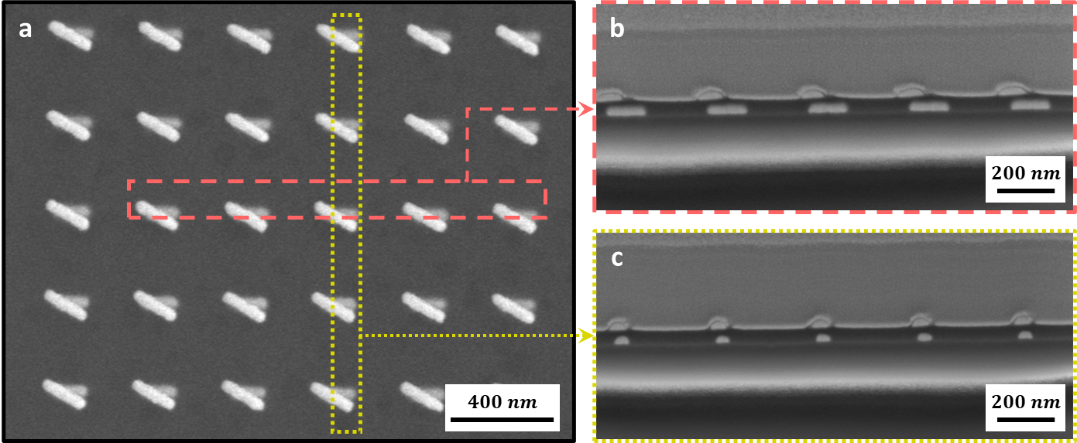
Fig. S4 SEM images of fabricated bilayer chiral structure. a) top-view image of the chiral nanostructure. b, c) cross-sectional view images of the chiral nanostructure using selective FIB milling process. b) horizontal direction cut (red box); parallel to nanorods orientation. c) vertical direction cut (yellow box); perpendicular to nanorods orientation. h_{s} = SU-8 spacer layer thickness.

Experimental characterization
For extracting the transmission phase of the device, our experimental system comprises a tunable source, a dispersion-cancelling free-space Mach-Zehnder interferometer (MZI), and a post-processing scheme based on fast Fourier transform to extract the phase response from interferograms captured by a camera. To cover the required wavelength range, we used a supercontinuum source (SuperK Fianium). An accessory wavelength selection module (SuperK SELECT) based on tunable acoustic-optic filtering extracts a single spectral line from the continuum spectrum and is swept to measure the data in Fig. 3 (main text).
The MZI setup entails careful polarization manipulation and dispersion canceling. Since any bulk optics, beam splitters, in particular, can have their intrinsic birefringence, the QWPs for converting the excitation source from linear polarization (LP) to circular polarization (CP), and vice versa, are placed within the two arms (denoted as sample arm and reference arm, respectively) of the interferometer. CP is generated, transmitted through the chiral device, and immediately converted to LP for interference after BS2. It is also essential to cancel chromatic dispersion for optimum interference across the spectrum. For this reason, the components (besides samples under test) in the two arms are identical and exactly mirrored: another pair of QWPs are placed in the reference arm. A dispersion-cancelling substrate consisting of the same glass substrate and SU-8 layer is also used in the reference arm, which allows the canceling of the phase due to the substrate and SU-8 in the device. The focusing lens is placed before BS1, thus does not introduce disparity in dispersion between the two arms, and also ensures the same beam diameters from the two arms given the same path lengths. With such settings, the source wavelength can be swept without losing coherence between the two arms.
After BS2, the two beams are merged with an intentionally arranged horizontal angle such that vertical stripes are formed in the interferogram measured by the camera. Two frames of images are taken for each measurement at each wavelength: one when the beam in the sample arm transmits through the nanorod array, and another when the sample is translated such that the beam passes through only the glass substrate and SU-8 layer. The latter forms the baseline phase that should be subtracted from the former, such that the resultant phase is responsible for that due to the array only. The reader should not confuse this subtraction with the dispersion-canceling substrate in the reference arm – the setting for the reference arm is responsible for ensuring coherence by minimizing residual chromatic dispersion. In contrast, here, we are referencing the extracted phase by removing a residual phase, which also corresponds to the contribution from the substrate.
To extract the phase, we perform a fast Fourier transform along horizontal line scans of the interferogram. An example of the resultant Fourier spectrum is shown in Fig. S5. The AC peaks correspond to the spatial frequency of the interference pattern. A phase difference can be visually perceived as shifted fringes and may be quantified as the phase of the complex amplitude of this AC peak. Subtracting the phases leads to the data in Fig. 3 of the main text; also see [Ref 49] for detailed derivations.
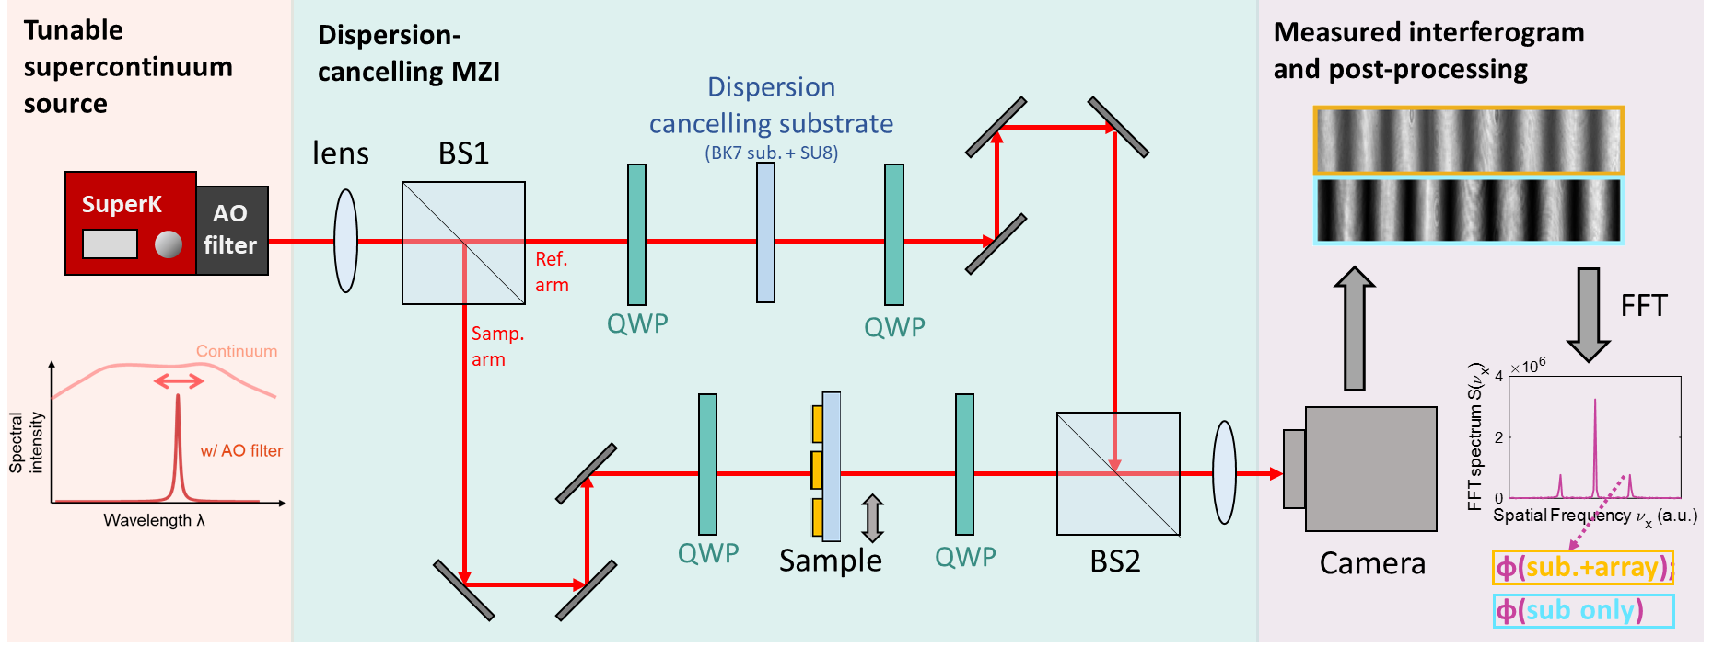
Fig. S5 Experimental scheme for extracting the transmission phase of the device. AO = acousto-optic; MZI = Mach-Zehnder interferometer; BS = beam splitter; QWP = quarter wave plate; Fast Fourier transform (FFT).

The experiment consists of an interference between a reference and a signal through the sample. As light source, we use a supercontinuum laser (from NKT photonics). The supercontinuum laser (NKT Photonics) paired with an acousto-optic tunable filter (SuperK), enabling precise selection of operating wavelengths within the range of 400 nm to 2000 nm. The system offers a spectral resolution on the order of nanometers (e.g., 2–5 nm FWHM). For our experiments, we ensured the metasurface was fully illuminated (100% coverage) with optical power around 10mW. The collimated white light beam was split into two by the un-polarized 50/50 wideband dielectric beam splitter for the reference and signal beams. The spectral intensities of the two beams are set to be approximately equal during the experiment in order to achieve a high fringe contrast of their interferogram and to reduce errors in the reconstruction process. To obtain the phase information from the interference pattern, we used the Fourier transform techniques . To accurately measure the phase many factors should be accounted for such as beam uniformity, ambient air, mechanical vibration, spatial and spectral resolution, number of fringes, camera noise, smooth substrate, and large sample area for the beam waist [Ref 49].
To investigate the chiral properties of our fabricated sample, we measured the transmittance spectra using right-handed and left-hand circularly polarized (RCP, LCP) light. We used a Fourier-transform infrared spectrometer system (Bruker Vertex 70, equipped with a tungsten lamp) coupled with an optical microscope (Bruker Hyperion). The microscope is fitted with a x15 Cassegrain objective (numerical aperture, NA = 0.4), and Si detector. A broadband linear polarizer and a quarter-wave plate are used to produce both right-handed and left-handed circularly polarized light. The transmittance spectra that are measured then normalized to the substrate.
Figure S6 depicts the experimental and simulated transmittance through six samples with a twisted angle ($θ$ = + 30º) and different lateral displacements (d_{x} = 0, 20, 40, 60, 80, and 100 nm) as shown in the corresponding SEM image in Fig. S3. In Figure S6, both the measured and simulated transmittance under right circularly polarized (RCP) excitation show two distinct dips. In contrast, a single prominent dip is observed for left circularly polarized (LCP) excitation." Additionally, altering lateral displacement (d_{x}) results in a shift in the resonance frequency of two hybridized modes [Ref 50]. This leads to an inversion in the plasmonic hybridization scheme, which occurs at d_{x} values ranging from 60 to 80 nm.
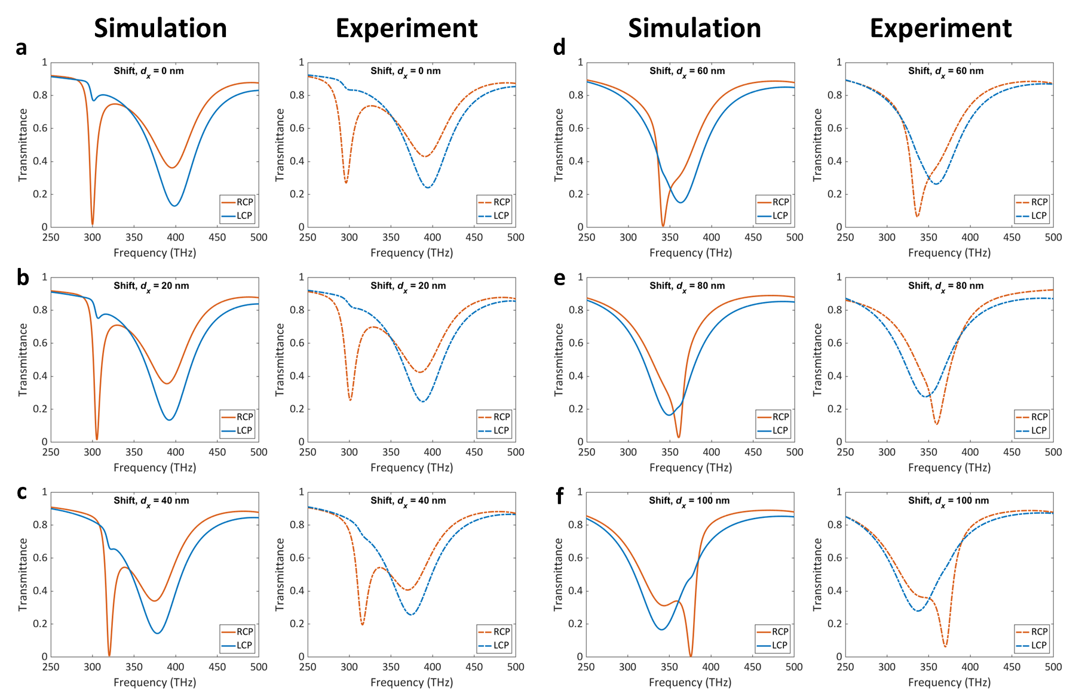
Fig. S6 Experimental and simulated transmittance spectra from the fabricated chiral structures with various lateral displacements (d_{x} = 0, 20, 40, 48, 58, 60, 80, and 100 nm, respectively).

In summary, the optical characterization and simulation results exhibit a good agreement. Theoretically, switching from right circularly polarized (RCP) light to left circularly polarized (LCP) light within the same optical configuration (e.g., at a twist angle of θ = 30°) is fundamentally equivalent to using two configurations with opposite angular orientations (e.g., θ = 30° and θ = -30°), while keeping the incident light conditions (LCP or RCP) unchanged. This symmetry arises because the change in polarization handedness reverses the interaction between the light and the system, producing the same effect as flipping the twisted angle. To avoid redundancy, figure S7 compared numerical results and experiments with the twist angles: θ = -30°. The main difference between Figures 3 and S7 is the twist angles: θ = 30° in Figure 3 and θ = -30° in Figure S7.
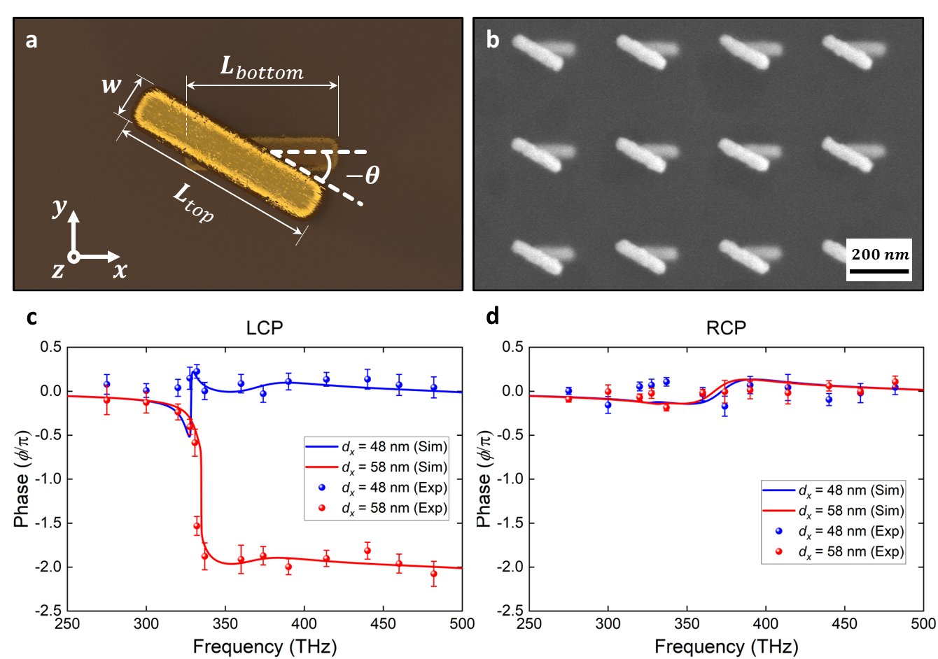
Fig. S7. Experimental observation of phase singularity in chiral medium. c and d present the comparison between numerical simulations and experimental phase responses of the hybridized plasmonic arrays of two spatially separated plasmonic twisted resonators at an angle ($θ$ = -30º) with LCP (c) and RCP (d) as the incident beams.

Robustness of phase singularity in chiral medium using three primary parameters using three different configurations. A max phase difference is calculated by subtracting the phase of the regular case from the phase jump case at the highest frequency. When a phase singularity exists in the system, the max phase difference is close to 2π. We can observe the max phase difference/π in the 3D plots of different sweeping variables in Figure 4 are all close to 2 (Surfaces are simulations, and dots are measurements). Thus, the proposed photonic device is robust, as fabrication imperfections cannot hinder the existence of the phase singularities.
To further demonstrate the robustness of our devices to fabrication imperfection, we also performed numerical simulations as function the impact of polarization which is the central design parameter. Figure S8 below compares the ideal scenario and the ratio of the desired polarization to the undesired polarization, which is defined as the impurity. The results clearly indicate that even with up to 20% polarization impurity, the device maintains a robust 2π phase shift. These results further demonstrate that the proposed device is highly resilient to polarization misalignment beyond the previously discussed parameters, confirming its robustness and practical applicability.

Table 1 Represent the value represent the experimental data to plot figure 4 of the paper with the three different configurations showing the robustness of the proposed structure.
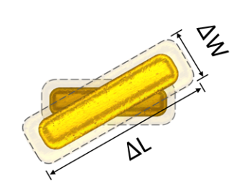 |  |  |  | 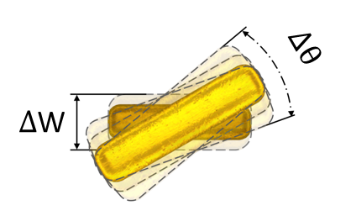 |  |  |  | 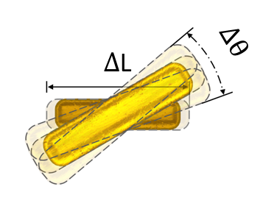
ΔL and ΔW |  |  |  | ΔW and Δθ |  |  |  | ΔL and Δθ
ΔL | ΔW | Phase differences |  | Δθ | ΔW | Phase differences |  | ΔL | Δθ | Phase differences
(nm) | (nm) | Sim | Exp | ( ˚ ) | (nm) | Sim | Exp | (nm) | ( ˚ ) | Sim | Exp
0 | 50 | 1.94π | 2.006π | 30 | 50 | 2.006π | 1.994π | 0 | 20 | 2.016π | 1.869π
0 | 60 | 1.85π | 2.002π | 30 | 60 | 2.002π | 1.901π | 0 | 30 | 2.006π | 1.877π
0 | 70 | 1.91π | 1.978π | 30 | 70 | 1.978π | 1.964π | 0 | 40 | 1.997π | 1.878π
10 | 50 | 1.88π | 2.003π | 40 | 50 | 1.997π | 1.931π | 10 | 20 | 2.011π | 1.957π
10 | 60 | 1.87π | 2.002π | 40 | 60 | 1.989π | 1.970π | 10 | 30 | 2.004π | 1.994π
10 | 70 | 1.95π | 1.986π | 40 | 70 | 1.970π | 1.986π | 10 | 40 | 1.997π | 1.970π
20 | 50 | 1.93π | 2.003π | 50 | 50 | 1.986π | 2.154π | 20 | 20 | 2.011π | 1.918π
20 | 60 | 1.88π | 2.002π | 50 | 60 | 1.974π | 2.078π | 20 | 30 | 2.003π | 1.965π
20 | 70 | 1.94π | 1.994π | 50 | 70 | 1.964π | 2.032π | 20 | 40 | 1.998π | 2.012π

To further validate the robustness of the proposed plasmonic device, we conducted comprehensive numerical simulations to examine the stability of the phase singularity under variations in key design parameters. Specifically, we investigated the combined influence of three primary parameters—width, length, and twisted angle (Fig. S9)—as well as the interlayer thickness of the SU8 spacer (Fig. S10). The simulations reveal that even when width, length, and twisted angle are varied simultaneously, the device consistently achieves a 2π phase shift, demonstrating remarkable tolerance to parameter fluctuations. This robust performance shows the resilience of the design against fabrication imperfections associated with geometric dimensions.

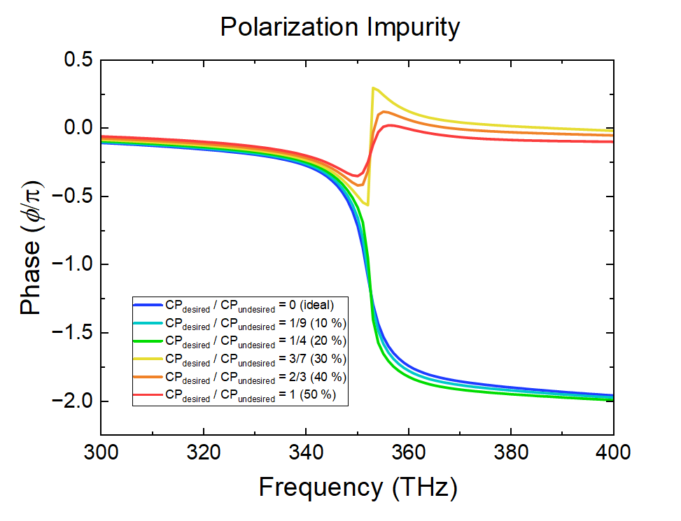
Fig. S8: Comparison between ideal polarization and the polarization misalignment

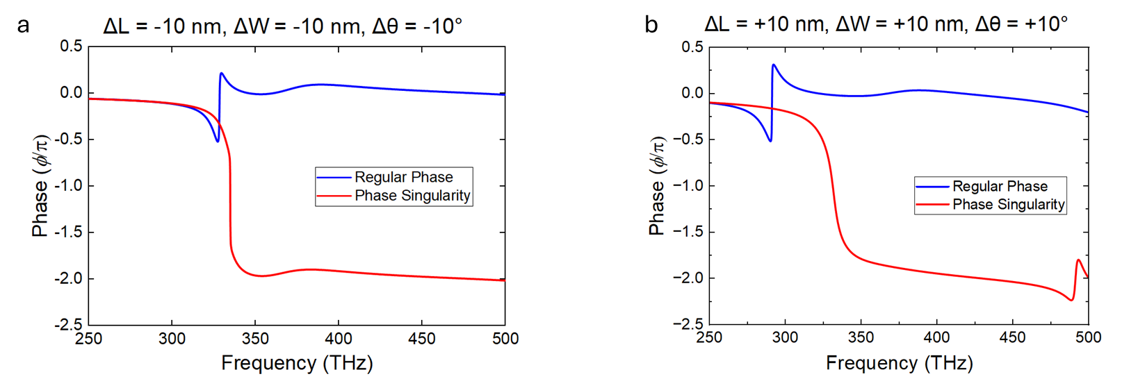
Fig. S9 Influence of three primary parameters combined—width, length, and twisted angle, a, width, length, and twisted angle -10. b width, length, and twisted angle +10.

Moreover, we analyzed the impact of deviations in the SU8 interlayer thickness (h), designed initially at h=60 nm. The results show that even with thickness variations of ±10nm (i.e., h=50nm or h=70 nm), the 2π phase shift remains unchanged. These results further confirm the robustness of our plasmonic device to fabrication imperfections, demonstrating its potential for reliable and scalable applications.
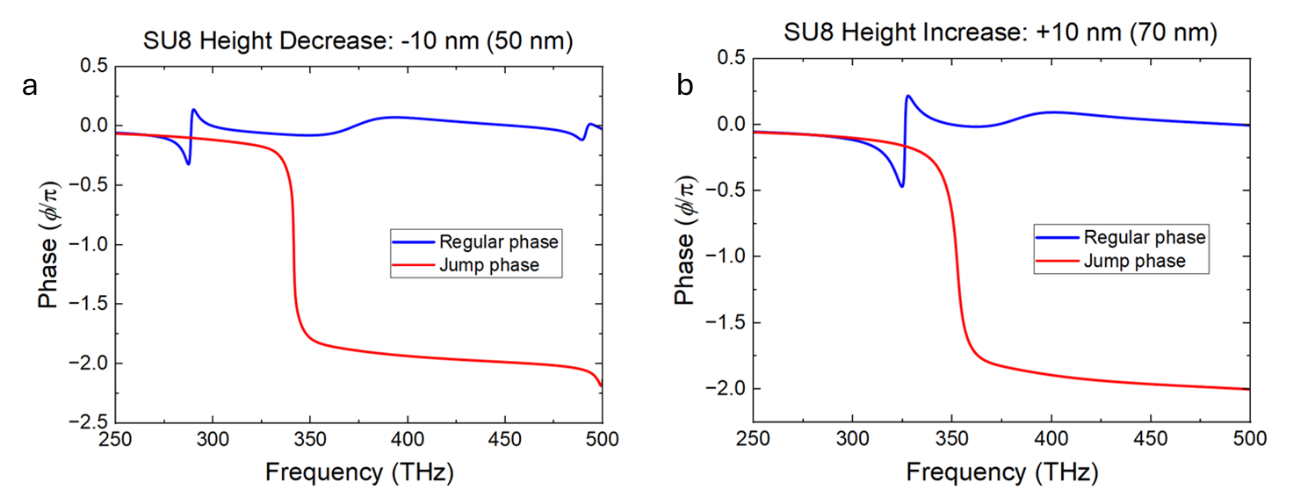
Fig. S10 a Phase singularity with interlayer thickness Su8 h=50 nm, b Phase singularity with interlayer thickness SU8 h=70 nm.

